Version <1.0>

Revision History

|  |  |  |  |
| --- | --- | --- | --- |
| **Date** | **Version** | **Description** | **Author** |
| <dd/mmm/yy> | <1.0> | <details> | Nguyen Kiem Hoa |
|  |  |  |  |
|  |  |  |  |
|  |  |  |  |

Table of Contents

1. Notify Event 4

1.1 Brief Description 4

1.2 Actor 4

2. Flow of Events 4

2.1 Basic Flow 4

3. Special Requirements 4

4. Preconditions 4

5. Postconditions 4

6. Extension Points 4

# Notify Event

## Brief Description

This use case defines the steps of notifying user about event realated to user’s image such as when someone like or comment user’s image. User can easily view notification through “Noti” tab.

## Actor

User

# Flow of Events

## Basic Flow

When someone like or comment on an image which user posted, content will be store in database. Then it will be retrieve to notify to author of that image about this event.

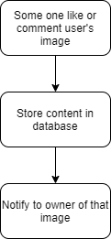

# Special Requirements

No special requirement.

# Preconditions

Someone like or comment on image of user.

# Postconditions

Notify event at user’s “Noti” tab.

# Extension Points

No extension point.